Project Design Phase-II
Data Flow Diagram & User Stories

Date | 28 November 2025
Team ID
Project Name | Flight Booking System
Maximum Marks | 4 Marks

Data Flow Diagrams:
A Data Flow Diagram (DFD) shows how information flows through the Flight Booking System.
It describes how different users—Passengers, Admins, and Airline Systems—interact with the platform, how flight and booking data move between components, and where passenger and booking information is stored or processed.
DFD Level 0 – Flight Booking System
The Level 0 DFD of the Flight Booking System presents a high-level view of the platform as a single main process.
It illustrates how external entities like Passengers, Admins, and Airline Systems exchange data with the Flight Booking System, without going into internal processing details. This helps in understanding the overall data flow into and out of the system.

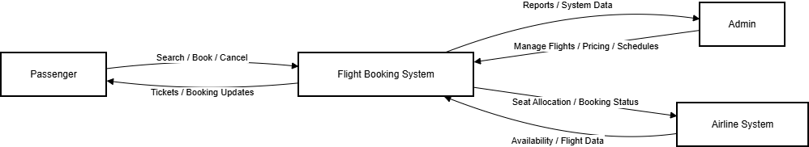

User Stories– Flight Booking System
User Type | Functional Requirement | User Story / Task | Acceptance Criteria | Priority | Release
Passenger | Flight Search | As a passenger, I can search for flights using date, origin, destination, and passenger count. | The system returns accurate flight results matching the search filters. | High | Sprint-1
Passenger | Flight Selection | As a passenger, I can select a flight and view fare, airline, timings, and seat availability. | Selected flight loads correct details and availability. | High | Sprint-1
Passenger | Passenger Details & Seat Selection | As a passenger, I can enter traveler details and choose preferred seats. | Traveler data saved and seat map loads correctly. | Medium | Sprint-2
Passenger | Booking & Payment | As a passenger, I can make a secure online payment to confirm the booking. | Payment successfully and PNR/ticket generated. | High | Sprint-2
Passenger | Booking History | As a passenger, I can view all my previous bookings. | Booking history displays correct past ticket data. | Low | Sprint-3
Admin | Flight Management | As an admin, I can add, edit, or remove flight schedules, pricing, and availability. | Updates reflect instantly across the system. | High | Sprint-1
Admin | Booking Monitoring | As an admin, I can view all bookings made by passengers. | Admin dashboard displays complete and accurate booking data. | Medium | Sprint-2
Admin | User Management | As an admin, I can manage passenger accounts and resolve issues. | User profiles updated and issued logs recorded successfully. | Medium | Sprint-3
Airline System | Real-time Flight Info | As an airline system, I can provide availability, fare, and schedule information to the platform. | The platform receives accurate real-time flight and fare data. | High | Sprint-1

